THREE DIFFERENT SORTING ALGORITHM COMPARISON
Experiment 1, Experimentation & Evaluation 2026

Abstract
This experiment compares the execution times of three given Bubble Sort implementations: PassPerItem, UntilNoChange, and WhileNeeded. Each algorithm sorts arrays of 1,000 elements containing Integer, Double, or String values. Inputs are either shuffled or reversed, considering 18 experimental conditions(3 algorithm x 3 types x 2 forms=18). Each condition measures 30 times in Java using System.nanoTime(), resulting in 540 (18 x 30) sorting-time observations. The data can be summarized such as (Min,Q1,Median,Q3,Max). Among all six combinations(3 different types and 2 different type orders) of input order and data type, WhileNeeded achieved the lowest median execution time across all six combinations of data type and input order.
1. Introduction
Sorting performance used depends on the algorithm and on the order and data type of its inputs. Bubble Sort provides a useful consept for comparing implementations with different stopping or scanning approaches. This study asks which of three provided Bubble Sort would finish sorting faster under the given conditions.
To investigate this question, the same 1,000-element input is given to all three algorithms within each repetition and data type, using separate copies. Two input orders (shuffled and reversed) and three data types (Integer, Double, and String) are tested, and sorting time period is recorded over 30 repetitions per condition.

Hypotheses:
H0-Null;There is no difference in sorting times of PassPerItem, UntilNoChange, and WhileNeeded.
H1: Because of its optimization based on the last swap position, WhileNeeded is expected to have a lower sorting time than PassPerItem and UntilNoChange.

2. Method
a.Open github repository from below link
https://github.com/YilmazGo/EXPERIMENT-01
b.Download the project files.
c. Simply hold the “BubbleSort_Experiment_VSCode” and drag it to your VS Code application(if you dont have please download it from the appstore)
d. Before touching anything read the README file.Follow the instructions.
e. After you read the file you execute the program according to read me file and you produce 2 new CSV files.
f. Open the excel file from the downloaded file (step b).And read the README tab at the end of the tabs of the excel file.Follow the instructions ansd copy the CSV files to the corresponding tabs(SHUFFLED DATA, RAW DATA TABS). Then your statistics and charts would be ready.

2.1 Variables

Independent variable | Levels
Sorting Algorithm  Input Order  Data Type | PassPerItem, UntilNoChange, WhileNeeded  Shuffled, Reversed  Integer, Double, String

Explicitly identify the dependent variable(s) (i.e., what you measure):
Dependent variable | Measurement Scale
Sorting execution time | Ratio (nanoseconds)

Control variable | Fixed Value
Array size  Repetitions  Measurement Method  Execution Environment | 1.000 elements  30  System.nanoTime()  My computer

2.2 Design

Type of Study (check one):
⃞ Observational Study | ⃞ Quasi-Experiment | ⃞ x Experiment

Number of Factors (check one):
⃞ Single-Factor Design | ⃞ x Multi-Factor Design | ⃞ Other

The design has 3x3x2 factorial design, why 3 different algorithm(PassPerItem, UntilNoChange, WhileNeeded), 3 different input data type(Integer, Double, String), 2 input data form(reversed and shuffled)=18. Every condition tested for 30 times, 18x30=540 measurements.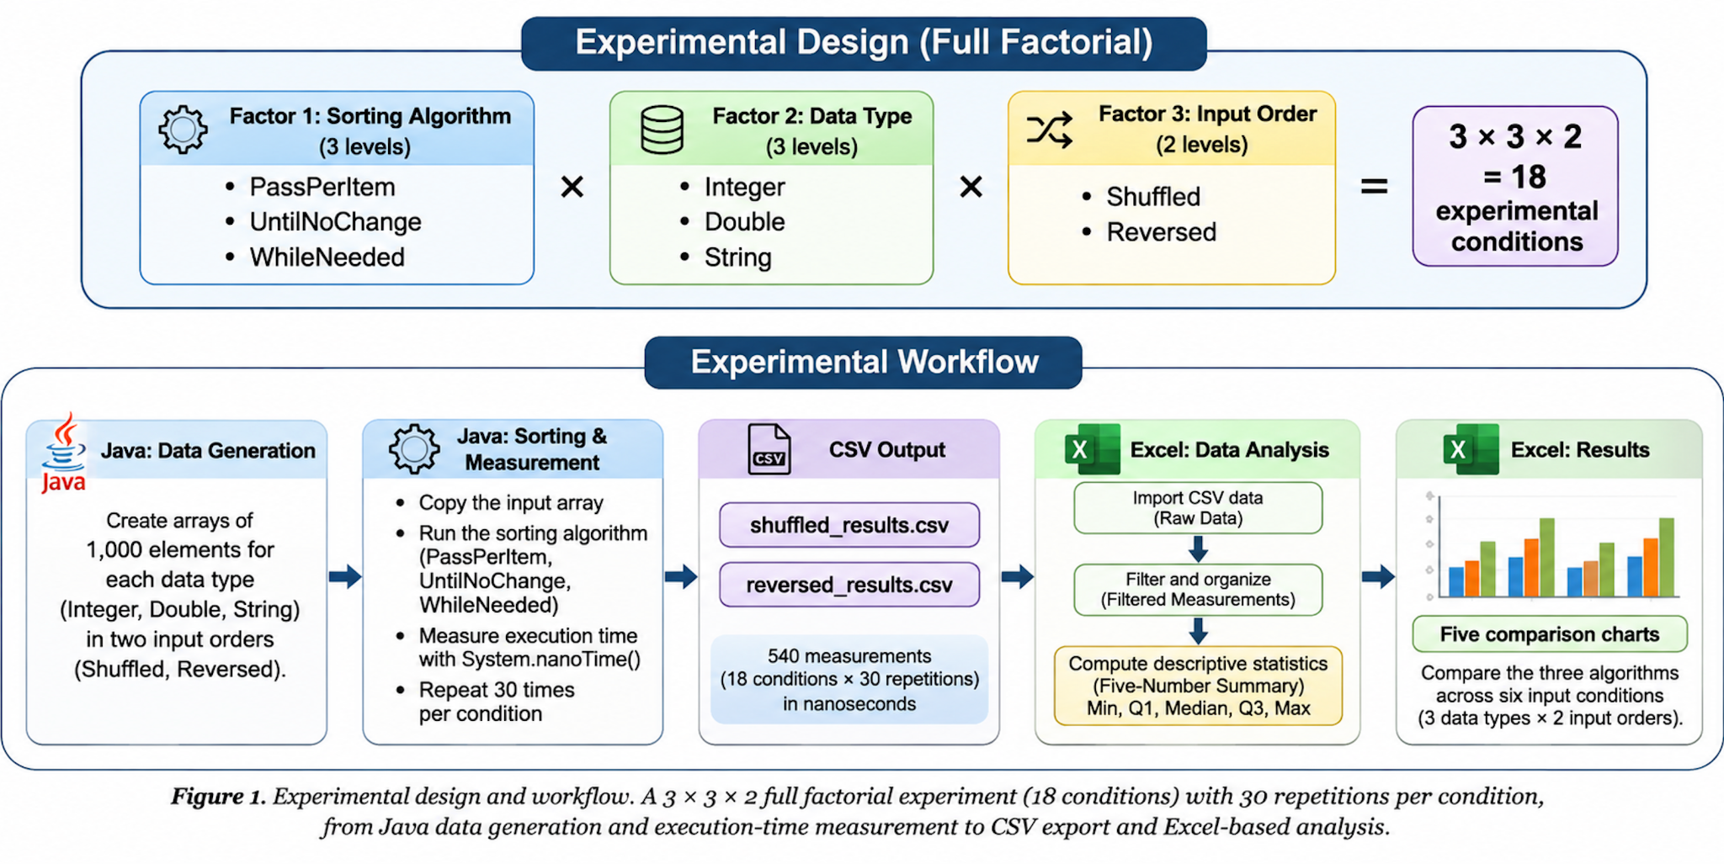

2.3 Apparatus and Materials
The experiment was done on an Apple MacBook equipped with an Apple M3 Pro processor and 18 GB of unified memory, running macOS.The experiment was implemented in Java using Visual Studio Code. Execution times were measured automatically using Java's System.nanoTime() method. The timer was started before each sorting operation and stopped after it. The elapsed time was calculated by subtracting the start timestamp from the end timestamp. No manual stopwatch was used.
The measurements were exported into two CSV files (shuffled and reversed) and analyzed using Excel work sheet. The analysis included the five-number summary (minimum, Q1, median, Q3, maximum) and six histograms.
The source code and analysis files are available at https://github.com/YilmazGo/EXPERIMENT-01.

2.4 Procedure
- First Visual Studio Code was opened on a MacBook with an Apple M3 Pro processor.
- ArrayData.java code was opened.The experiment parameters were set to an array size of 1,000 elements and 30 repetitions per experimental condition and executed(manually).
- Reversed and Shuffled Experiment java codes were opened and executed(manually).
- The program generated arrays containing Integer, Double, and String values. For each data type, two input forms were prepared: Shuffled and Reversed.
- For each sorting operation, the program created a copy of the input array so that the original data remained unchanged. The execution time was measured using System.nanoTime()method, starts before the sorting operation and stops after it. The difference between the two timestamps gives the sorting execution time in nanoseconds.
- After the measurements were done, the program saved the results in two CSV files: shuffled_results.csv ,reversed_results.csv. Each record composed of ; algorithm name, data type, repetition number, and execution time(automatically,).
- Finally, the CSV files were copied manually into Excel. The measurements were organized by experimental condition, converted from nanoseconds to milliseconds in order to represent it easily, and used to calculate the minimum, Q1, median, Q3, and maximum execution times. Histograms were designed to compare the algorithms across the six input conditions.
In total, the experiment produced 540 execution-time measurements across 18 experimental conditions.

3. Results

3.1 Visual Overview
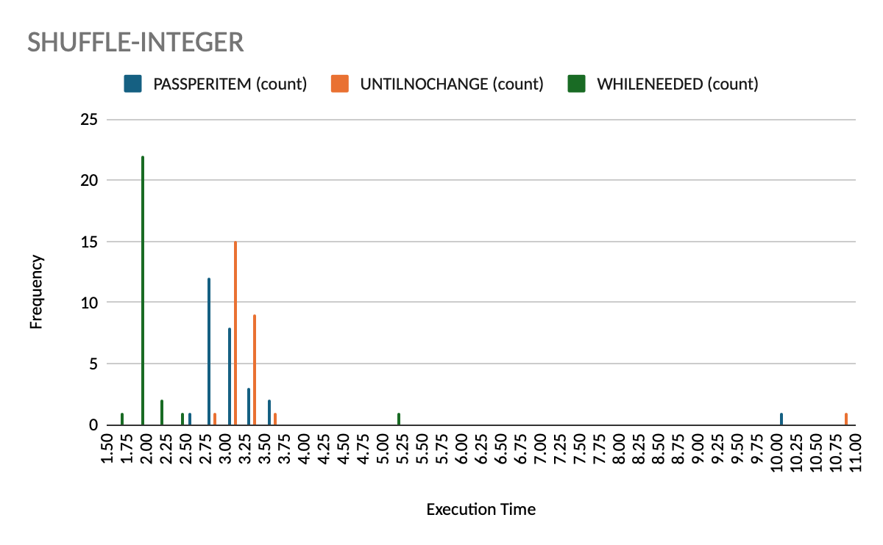
Figure-1

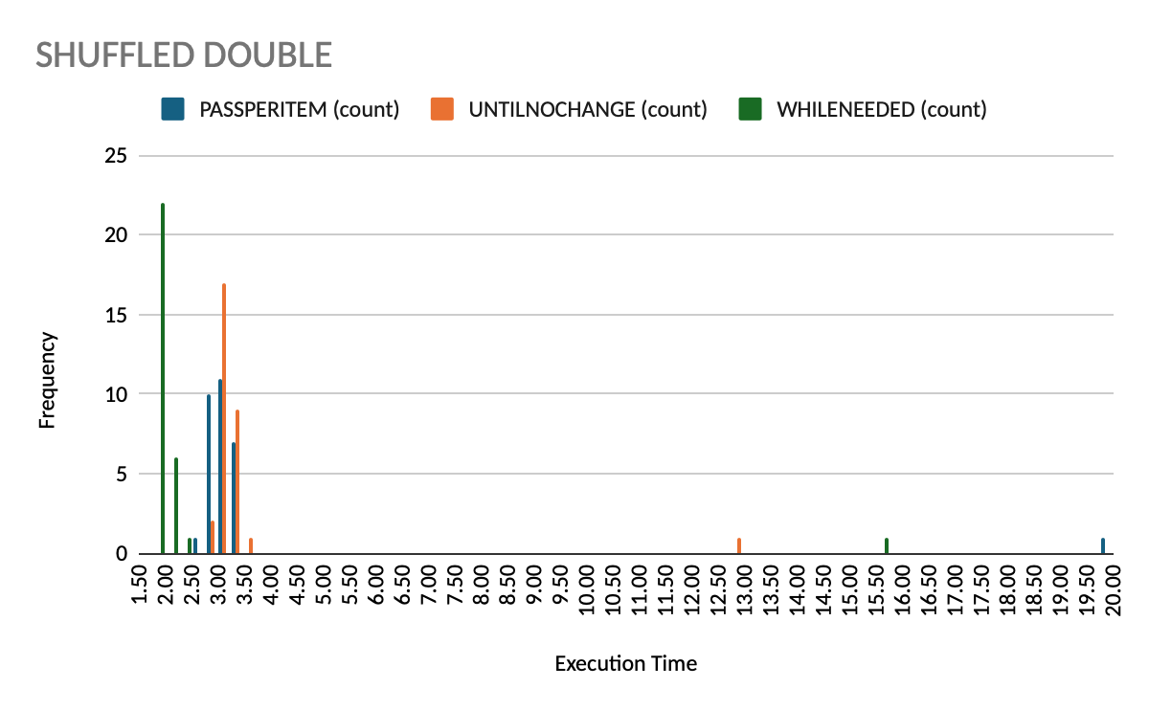
Figure-2
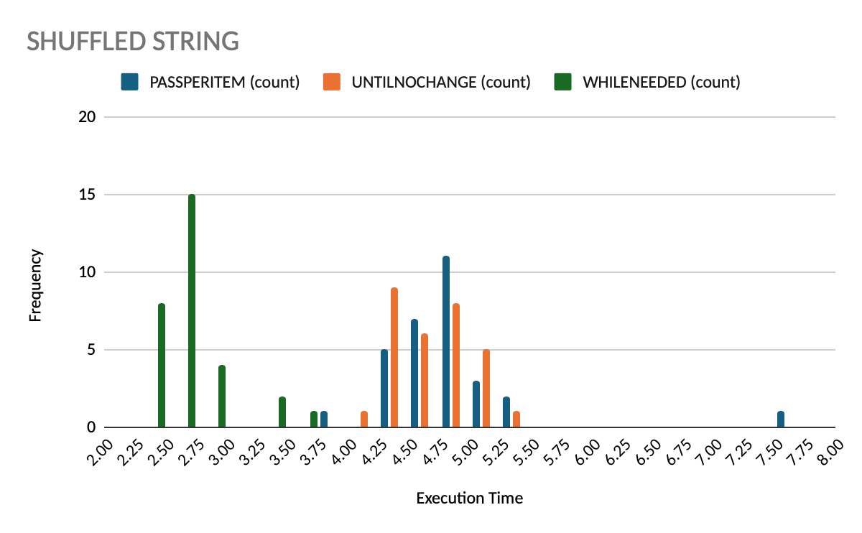
Figure-3

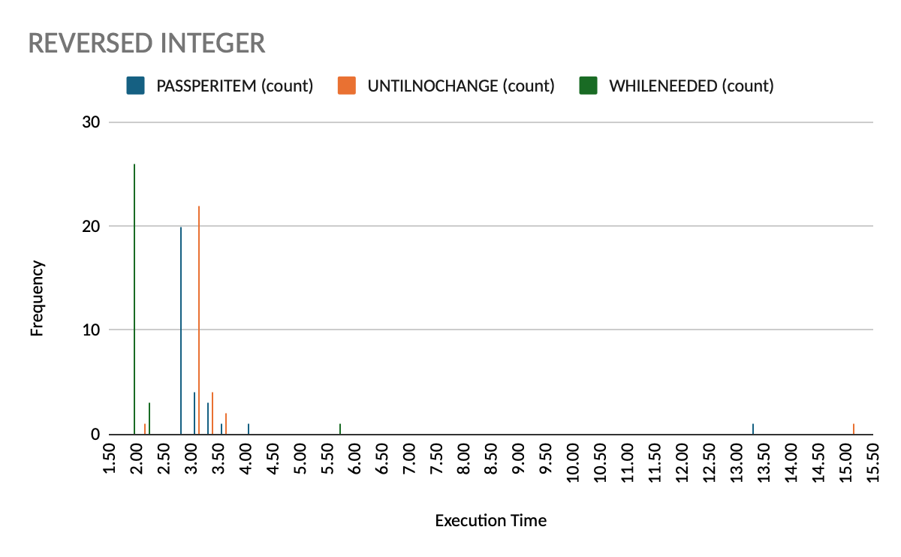
Figure-4

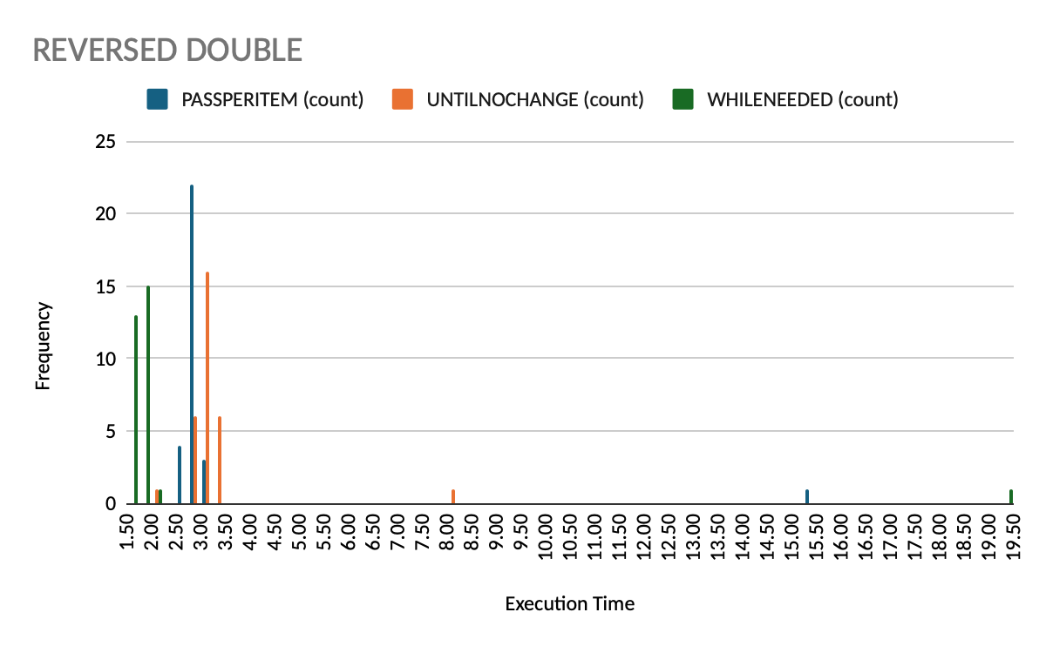
Figure-5

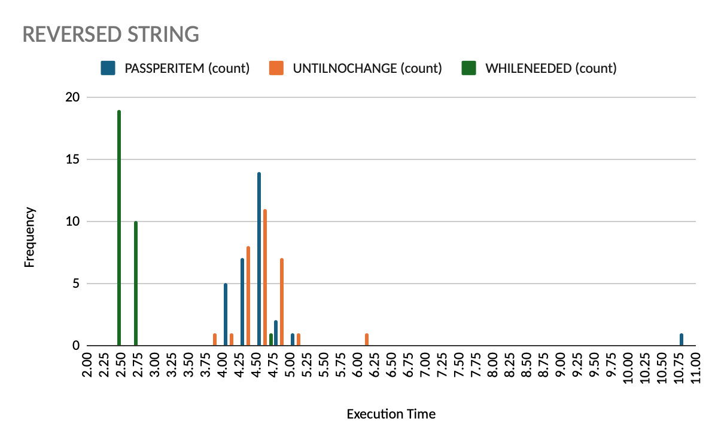
Figure-6

Figure-1;The histogram for shuffled Integer arrays shows that WhileNeeded execution times are clustered around 1.75–2.00 ms, whereas PassPerItem and UntilNoChange are mainly clustered around 2.75–3.50 ms.This indicates that WhileNeeded generally achieves lower execution times under this experimental condition.
Figure-2;The histogram shows that WhileNeeded has the lowest execution times, with most measurements clustered around 1.8–2.1 ms. PassPerItem and UntilNoChange are mainly clustered around 2.8–3.5 ms
Figure-3;The histogram shows that WhileNeeded has the lowest execution times, with most measurements clustered around 2.4–2.8 ms. PassPerItem and UntilNoChange are mainly clustered around 4.3–5.2 ms. WhileNeeded is clearly faster, while PassPerItem shows a few higher execution times.
Figure-4;The histogram shows that WhileNeeded has the lowest execution times, mostly clustered around 1.75–2.00 ms. PassPerItem and UntilNoChange are mainly clustered around 2.75–3.50 ms. A few unusually high values appear in the first repetition, but WhileNeeded remains the fastest overall.
Figure-5;The histogram shows that WhileNeeded has the lowest execution times, mostly clustered around 1.7–2.0 ms. PassPerItem and UntilNoChange are clustered around 2.7–3.4 ms. All three algorithms show unusually high values in the first repetition, particularly WhileNeeded.
Figure-6;The histogram shows that WhileNeeded has the lowest execution times, mostly clustered around 2.3–2.7 ms. PassPerItem and UntilNoChange are mainly clustered around 4.1–4.9 ms. PassPerItem also shows an unusually high execution time in the first repetition.
Result; 540 execution-time measurements were collected across 18 experimental conditions, with 30 repetitions per condition.
Six histograms were designed to see the distribution of execution times for the three sorting algorithms in different data types (Integer, Double, and String) and input orders (Shuffled and Reversed). All execution times are presented in milliseconds, using a bucket size of 0.25 ms.(In order to see whole execution span in one frame (Histogram menu, custom tab)
Generally, histograms show that WhileNeeded measurements are generally clustered at lower execution times than those of PassPerItem and UntilNoChange. Execution times for String arrays are generally higher than those for Integer and Double arrays.

3.2 Descriptive Statistic

Input order | Data type | Algorithm | Minimum (ms) | Q1 (ms) | Median (ms) | Q3 (ms) | Maximum (ms)
Shuffled | Integer | PassPerItem | 2.736 | 2.899 | 2.999 | 3.173 | 10.118
Shuffled | Integer | UntilNoChange | 2.883 | 3.069 | 3.178 | 3.318 | 10.759
Shuffled | Integer | WhileNeeded | 1.728 | 1.849 | 1.902 | 1.945 | 5.003
Shuffled | Double | PassPerItem | 2.686 | 2.962 | 3.109 | 3.256 | 19.945
Shuffled | Double | UntilNoChange | 2.785 | 3.119 | 3.200 | 3.344 | 12.810
Shuffled | Double | WhileNeeded | 1.808 | 1.902 | 1.946 | 1.999 | 15.578
Shuffled | String | PassPerItem | 3.978 | 4.555 | 4.761 | 4.958 | 7.732
Shuffled | String | UntilNoChange | 4.232 | 4.442 | 4.715 | 4.929 | 5.271
Shuffled | String | WhileNeeded | 2.421 | 2.495 | 2.595 | 2.742 | 3.635
Reversed | Integer | PassPerItem | 2.768 | 2.789 | 2.883 | 3.118 | 13.353
Reversed | Integer | UntilNoChange | 2.090 | 3.049 | 3.124 | 3.223 | 15.103
Reversed | Integer | WhileNeeded | 1.760 | 1.776 | 1.801 | 1.952 | 5.522
Reversed | Double | PassPerItem | 2.743 | 2.767 | 2.851 | 2.920 | 15.416
Reversed | Double | UntilNoChange | 2.220 | 3.005 | 3.058 | 3.229 | 8.120
Reversed | Double | WhileNeeded | 1.671 | 1.735 | 1.788 | 1.875 | 19.252
Reversed | String | PassPerItem | 4.117 | 4.399 | 4.609 | 4.677 | 10.995
Reversed | String | UntilNoChange | 3.894 | 4.452 | 4.608 | 4.790 | 6.016
Reversed | String | WhileNeeded | 2.312 | 2.396 | 2.440 | 2.537 | 4.664

Table shows us the five-number summary for each of the 18 experimental conditions, based on 30 measurements per condition. All execution times are expressed in milliseconds.
The minimum and maximum represent the shortest and longest recorded execution times. The first quartile (Q1) indicates the value below which approximately 25% of measurements have been executed, while the third quartile (Q3) shows us approximately 75% of measurements have been executed.The median represents the middle value of the measurements(middle index).

4. Discussion

4.1 Compare Hypothesis to Results
My null hypothesis (H0) states that there is no difference in sorting times among PassPerItem, UntilNoChange, and WhileNeeded. The alternative hypothesis (H1) predicts that WhileNeeded has a lower sorting time because of its last-swap code line.
The results show that WhileNeeded achieved the lowest median execution time in all six experimental conditions. The histograms also show that WhileNeeded execution times are exceptionally lower than those of the other two algorithms. The observed results support H1 rather than H0.

4.2 Limitations and Threats to Validity
First, all measurements were executed on a my MacBook with an Apple M3 Pro processor and 18 GB of memory. So the results may be different on other computers.
Second, only arrays of 1,000 elements were tested. Different array sizes may affect the performance of the algorithms.
To improve the experiment, future studies could test different array sizes, use multiple computers.

4.3 Conclusions
This experiment compared three Bubble Sort algorithms: PassPerItem, UntilNoChange, and WhileNeeded, using Integer, Double, and String arrays in Shuffled and Reversed order.
The results showed that WhileNeeded consistently achieved the lowest median execution times across all six input conditions, supporting the alternative hypothesis (H1).
Overall, the experiment suggests that the last-swap code line used by WhileNeeded can improve Bubble Sort performance under the tested conditions.But for further experiments with different array sizes and different computers would be needed to determine whether these findings can be generalizabile..

Appendix

A. Materials
The experiment was executed using Java in Visual Studio Code. The source code and generated datasets are included in the package described below.

B. Reproduction Package (or: Raw Data)
The reproduction package contains the Java source code, the raw experimental measurements, and the Excel workbook used for data analysis.
The raw data consists of 540 execution-time measurements stored in two CSV files: shuffled_results.csv and reversed_results.csv. Each file contains 270 measurements.
The Excel workbook contains the five-number descriptive statistics summaries and histograms presented in this report.
The source code and instructions for running the experiment are available in the GitHub repository:
https://github.com/YilmazGo/EXPERIMENT-01
These files allow the experiment to be repeated and the results can be produced by other cliensts as well..

